MACH4METAL

metalworking machinery
Transito 21
6909 DA BABBERICH Netherlands
Tel. +31 (0)316-247123
Fax: +31 (0)316-247956
info@mach4metal.com
www.mach4metal.com

Bank No : 66.52.13.883
IBAN : NL33 INGB 0665 2138 83
BIC : INGBNL2A

SIMASV Profile bender
Heavy version – Fully hydraulic

- Make : SIMASV Italia
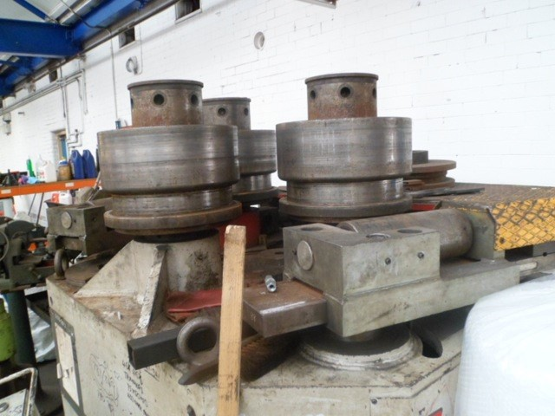
- Typ : CHP 125
- YOP : 2002
- No : M 1470

- Ø Schaft : 135 mm
- Ø Rol : 430 mm
- Bending speed : 0 – 7 m/min.

- Bending capacity:
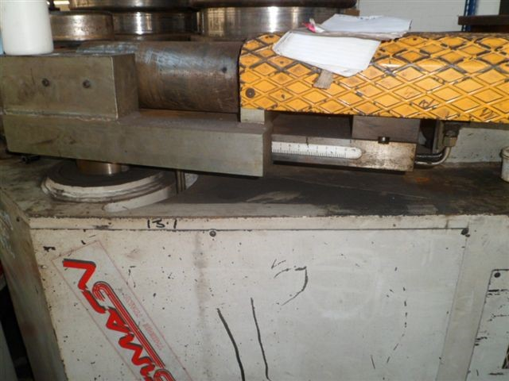

- Flatt iron edge : 140 x 30 mm
- Flatt iron flat : 220 x 50 mm
- Square bar : 85 mm
- UNP profile : 260 x 90 mm
- INP profile : 260 x 113 mm
- Tube : 168.3 x 5 mm

- Dimensions
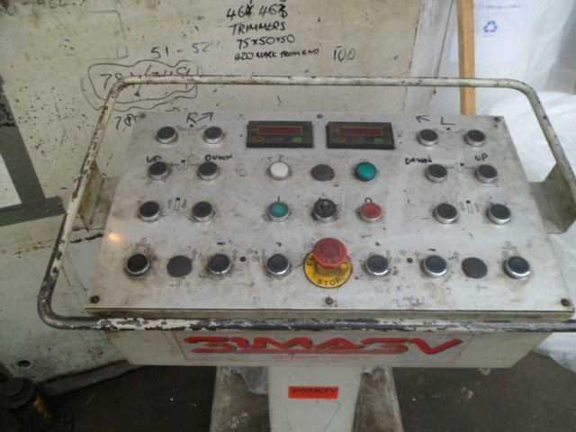
- Length : 1.750
- Width : 2.020
- Height : 1.950
- Weight : 6.900

- Hydraulic side support
- Digital readout
- Vario bending speed
- Set universal rolls

Please Note: The above information has been obtained to the best of our ability and belief from, and from the manufacturers where possible. It is given in good faith, but its accuracy can not be guaranteed. Accordingly, it will not form a representation or constitute contractual terms. We advise you to check any vital details!

